Greater Melbourne Urban Water & System Strategy: Water for Life
Summary

We respectfully acknowledge First Nations people as the Traditional Owners and custodians of the water and land throughout our catchment area. We also acknowledge the Traditional Owners of Country throughout Australia and recognise their continuing connection to waters, land and culture. We pay our respects to their Elders past, present and emerging.
In the spirit of reconciliation, we remain committed to establishing and maintaining partnerships with local Traditional Owners to ensure their ongoing contribution to the future of the water management landscape while maintaining their cultural and spiritual connections.

Foreword

Water is essential to making Greater Melbourne a vibrant, liveable and sustainable place both now and in the future. It underpins the health of people and the environment, enhances community wellbeing, and supports economic growth and jobs.

It is our pleasure to share this Water for Life strategy, which has been prepared collaboratively by Greater Western Water, Melbourne Water, South East Water and Yarra Valley Water. It delivers on the requirement under the Water for Victoria planning framework that every five years Melbourne Water and retail water corporations produce the Melbourne System Strategy and urban water strategies, respectively.
The strategy builds on the work we are already delivering to provide our region with a secure and sustainable water supply for the next 50 years. As water corporations, we are continually forward planning and preparing for long-term changes in our operating environment. This future focus has allowed us to identify multiple possible future scenarios and challenges ahead of time.
Melbourne is consistently ranked as one of the world’s most liveable cities and water makes a significant contribution to the prosperity of our people and places. We are one of Australia’s most water efficient capital cities, ambitious to do even more to ensure we use water wisely. In response we are encouraging households to take the next step by changing Melbourne’s daily drinking water-use target from 155 litres per person per day to 150 litres per person per day. Simple changes at home can add up to significant water savings overall. But that won’t be enough.
Today, our water storage levels are high and, with significant annual contributions from our first desalination plant, the Victorian Desalination Project, our water supply system delivers safe and reliable services to more than five million people. However, over time, we will need to add new sources of water to further supplement our water supplies. Climate change is affecting the reliability of our traditional water sources due to lower rainfall – in some catchments we have seen water availability decline by 15 to 20 per cent. Climate change is also affecting our environment and landscape, with hotter and drier conditions threatening biodiversity and liveability.
This is exacerbated by our rapidly growing population. Historically, Victoria has seen significant annual population growth, and though the COVID-19 pandemic has slowed this increase for now, long-term projections show our population is still expected to double by 2070 – further increasing demand for water. Urbanisation is also increasing the amount of sewage and stormwater our systems need to manage.
Our water storage levels can change quickly and we need to be prepared for conditions more severe than the Millennium Drought experienced between 1996 and 2010, during which levels dropped 50 per cent in four years. Collectively – water efficiency measures, local integrated water management solutions and new manufactured water sources – provide a portfolio of management actions to address this emerging challenge.
The best time to act is the present, while storages are high and we have the benefit of time. We must start investing in readiness now to ensure our systems remain resilient to the challenges presented by our growing city and drying climate. This allows us to consider multiple options and make the best informed decisions for the community. Investing at the right time lowers the overall cost of water supplies in the long term.

Building system resilience will be key to managing future climate variability. To provide a secure water future, a supply system augmentation of manufactured water will be required within the next 10 years, and potentially several additional augmentations are needed over the next 50 years.

This strategy aims to balance the water needs in our region by finding more efficient ways to use the water we already have, increasing our use of diverse water sources and using more climate resilient, manufactured water supplies (desalination, fit-for-purpose recycled water and treated stormwater). In the near term, manufactured water sources will largely come from additional desalination supplies because it can be supplied directly into the drinking water system, is completely rainfall independent and can operate at its full design capacity immediately after construction.
Melbourne is one of Australia's fastest growing capital cities with increasing urbanisation – which means we have a lot of people in a concentrated area – that is quickly spreading to regional areas. With more people comes more sewage to manage, and built-up areas divert more stormwater to our drains. This presents a great opportunity to put these water sources to better use. In the medium to longer-term (by 2070) the region will need to dramatically increase the use of recycled water, treated stormwater, and rainwater via household tanks for non-drinking purposes to complement desalinated water supplies and supply up to 20 per cent – or 200 gigalitres (GL) per year – of non-drinking water needs across Greater Melbourne. These sources not only reduce pressure on drinking water supplies, they contribute to improving urban amenity and waterway health. We have also set an ambitious target of approximately 55 GL of water to be returned to major rivers in the Greater Melbourne and Barwon region over the next 10 years to meet environmental outcomes.
The strategy also seeks to mature our relationships with Traditional Owners beyond collaboration, by honouring and respecting Traditional Owners’ status as our partners in water resource management. Our service region includes, or receives water from, the Traditional Country of the formally recognised Bunurong, Dja Dja Wurrung, Gunaikurnai, Taungurung, Wadawurrung and Wurundjeri Woi Wurrung Traditional Owner groups (see Figure 3). Together, we collaborated on the development of this strategy to ensure Traditional Owner priorities and cultural values are embedded in water management decision making and planning.
To strengthen the voice of the broader community, the Water for Life Community Panel was independently recruited to develop the strategy vision and a set of community criteria against which we tested our options for the future. Collaboration between the metropolitan and regional water corporations, our Traditional Owner partners, our customers and our communities has been essential to the development of this strategy.
While we are proposing significant investment in our services, we are also mindful that some of our customers have been adversely affected by the current economic climate, with high inflation, a rise in interest rates and increases in day-to-day living costs causing financial hardship. While these conditions are a challenge for everyone, some in our community are affected more than others, and we have a range of programs and support available for them. Keeping water bills affordable and easing cost of living pressures is central for decisions on the region’s future water supplies.
We are grateful for the collective input to date, which is reflected throughout this strategy. These collaborations will continue to drive successful implementation of the strategy. We look forward to the next five years (and beyond) as we deliver the actions and aspirations set out in the strategy and secure our water future together.

Maree Lang, Managing Director Greater Western Water
Nerina Di Lorenzo, Managing Director Melbourne Water
Lara Olsen, Managing Director South East Water
Pat McCafferty, Managing Director Yarra Valley Water

Our strategy on a page

Our challenge
Melbourne is growing and our climate is changing. Given this uncertain future, we need to plan now to find long-term water solutions for our customers and communities. How do we confidently meet our diverse water needs for the next 50 years?
Key challenges over the next 50 years:
Our climate is changing
Victoria will be warmer and drier
- There will be less water in our rivers and streams, and less water flowing into our supply system
- Building system resilience is key to managing climate variability.

Our population is growing
The amount of people in Victoria could double by 2070
- More people and urbanisation means there will be greater demand for our services
- By 2070, we could need up to 600 gigalitres (GL) of extra water each year

Our region is changing
We must balance environmental, economic and cultural water needs
- We need more water for the environment to keep our rivers healthy and support liveable communities.
- We also need to support Traditional Owner access to water
- Significant investment will be required over the next 50 years – timely and appropriate investment will keep prices affordable for our customers
Community vision
Our Melbourne. Our Water. Our Responsibility.
A future with:
- innovation driving equitable access to water
- pristine, precious, secure and sustainable water
- meaningful partnerships with Traditional Owners
- meaningful engagement with consumers
Ensuring a secure and sustainable water supply
Our objectives
We need to be prepared for a future where Greater Melbourne’s population is growing and the impacts of climate change and variability are uncertain. To do this, we will develop an Adaptive Plan that positions our water supply system to:
- make maximum use of the diverse range of available water sources
- use the water we already have efficiently
- transition to a more climate resilient supply of manufactured water.

Equitably and affordably meeting diverse water needs
In planning to provide water to a growing population, we need to ensure our essential services remain affordable to customers, while also supporting Traditional Owner access to water and equitable access for future generations.
Ensuring healthy people, healthy environment
We will deliver integrated water management (IWM) initiatives to support community liveability, wellbeing and urban amenity across the Greater Melbourne region. This can be achieved by making better, more productive use of rainwater and stormwater runo . To support community and Traditional Owner values, we will work together to protect waterway health and cultural values of our landscapes, as well as protecting our landscapes from extreme events and emergencies where possible.
Meaningful partnerships, engagement and education
To best address our future water challenges, we will develop a shared plan with community and Traditional Owners. In order to share the true value of water with communities, we need to deliver meaningful engagement and transparent decision making about the future and commit to listening and responding to community views and concerns. We also need to establish genuine partnerships with Traditional Owners by working together in water management and planning to deliver benefits to the whole community.

What we will do in the next five years
- Invest in readiness activities to prepare for the next supply system augmentations
- Investigate additional climate independent manufactured water sources
- Continue working with Government (via the CGRSWS) on the process for future augmentation decisions
- Support Government (via the CGRSWS) and deliver on commitments to return water to Traditional Owners and the environment
- Invest more in water efficiency initiatives
- Increase community involvement in future water supply planning
- Empower community to take a more active role in water efficiency
- Establish partnerships with Traditional Owner groups

About this strategy
The Victorian Government’s water planning framework considers all aspects of the urban water cycle across a 50-year period.
Under this framework, every five years Greater Melbourne’s retail water corporations – Greater Western Water, South East Water and Yarra Valley Water – are required to revise their urban water strategies. Melbourne Water, as a wholesale service provider, is required to revise the Melbourne Water Supply System Strategy. This ensures that our water plans are regularly reviewed to take into consideration changes in our operating environment, new knowledge and best practice.
The individual strategies were last reviewed in 2017 with a high level of collaboration. Ahead of the 2022 review process, we agreed to build on this collaborative approach by producing a single joint strategy – Water for Life – in partnership with neighbouring regional water corporations. This strategy builds on the strong foundation set by the 2017 strategies, combining their significant effort into a single, integrated and enhanced strategy covering the entire Greater Melbourne region.
This strategy – also referred to as the Greater Melbourne Urban Water and System Strategy (GMUWSS) – delivers on these requirements for Greater Melbourne’s water corporations – Greater Western Water, Melbourne Water, South East Water and Yarra Valley Water. Producing a joint strategy provided the opportunity to build on our core service offerings and the many ways we, as water corporations, already collaborate. As an industry, referred to as the water sector throughout this strategy, we are working together to achieve the best outcomes for the people and places in our service regions and to support regional water needs in connected systems.
This strategy is focused on delivering long-term solutions for the community and taking action now to ensure we are ready to add significant volumes of water to our supply over time.
The intent of this strategy is to answer a critical question:
How do we best work together to develop a clear plan for a secure and sustainable supply of water now, and for generations to come?
Our community’s voice
We have worked with our customers and the broader Greater Melbourne community to develop this strategy. In planning for the future, the strategy vision was independently developed by the Water for Life Community Panel with a set of criteria to assess future options for water security through a deliberative process, overseen by external facilitators.
Learning from the Traditional Owners of Country
In recognition of Traditional Owners’ status as partners in water management and respect for their self-determination, we sought to continue to strengthen collaborative relationships with each of the formally recognised Traditional Owner groups across our service region – the Bunurong, Dja Dja Wurrung, Gunaikurnai, Taungurung, Wadawurrung and Wurundjeri Woi Wurrung Traditional Owner groups.

We worked together to set the direction for the strategy and assess future options for water security. The key success factors identified for Traditional Owners have informed the direction and focus for the strategy and also its outcomes. Together we co-developed key aspirations that support our common objectives and specific on-Country objectives for Traditional Owners. These aspirations have been embedded as actions within the strategy.

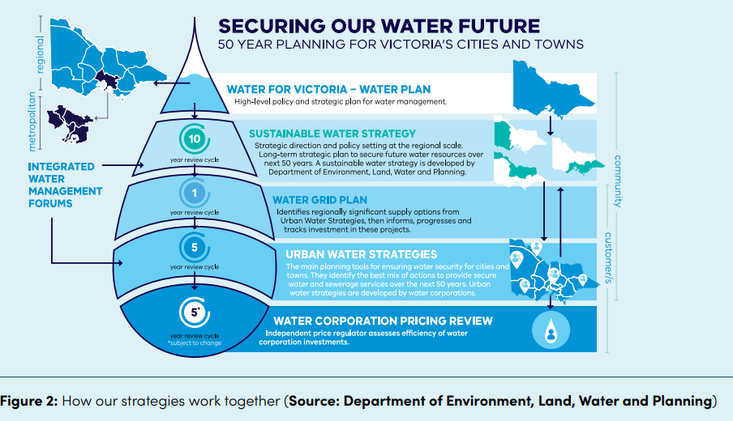
Water management context for Greater Melbourne
In Victoria, water is managed through a 50-year planning framework (see Figure 2). By planning and managing all elements of the urban water cycle in an integrated and innovative way, we can ensure that we support a healthy environment, a prosperous economy and thriving communities.
Water for Victoria, is the state’s high-level policy and strategic plan for water management, which sets the long-term policy direction for managing Victoria’s precious water resources.
Sustainable water strategies are developed by the Department for Environment, Land, Water and Planning (DELWP) on behalf of the Minister for Water every 10 years to set the strategic direction and policy settings for the region, considering all water needs (urban, agricultural, Traditional Owners, environmental and recreational).
- The Central and Gippsland Region Sustainable Water Strategy (CGRSWS) (DELWP, 2022) has been developed in parallel with and has informed the policy directions of this strategy. The two strategies work together to secure water for our community's future needs. In addition to these existing instruments, going forward, planning for regionally significant urban water supply options will be progressed via a new Water Grid Plan. These options will be identified from urban water strategies and additional investigations undertaken by water corporations and the Victorian government to meet predicted supply shortfalls. Water corporations will work with the Victorian Government and other relevant stakeholders to take a ‘system-wide’ view, including undertaking initial investigations into regional scale options such as future desalination.

The Water for Life strategy delivers on the requirement under the Water for Victoria planning framework that every five years Melbourne Water and retail water corporations produce the Melbourne System Strategy and urban water strategies respectively.
- The Melbourne Water System Strategy presents a system view of water resource management across metropolitan Melbourne and the surrounding regions for the next 50 years.
- Urban water strategies include plans for securing water supplies for the next 50 years given uncertainty with population, climate change and climate variability. They also include drought preparedness plans which detail how acute future water shortages will be managed.
Integrated Water Management (IWM) Forums have been established for individual catchments across the Greater Melbourne region to identify, prioritise and oversee the implementation of collaborative water management opportunities. An IWM approach plans for and manages all elements of the water cycle, including how we manage and protect the health of our waterways and bays, sewage management, using all sources of water to supply fit-for-purpose water, stormwater management and water treatment.
Price submissions are typically developed in parallel with urban water strategies. Each water corporation develops a pricing proposal for submission to the Essential Services Commission (ESC), the independent economic regulator for Victoria’s water sector. They set out key strategies, projects, initiatives and operational requirements that impact future pricing. This strategy integrates with and informs price submissions.

Who we are
As water corporations, our role is to provide Greater Melbourne with safe and secure access to water supply and sewerage services. In addition, Melbourne Water is responsible for drainage and waterway management, while also delivering water to regional areas and the environment.

These essential services support a healthy environment, strong economy and liveable communities in the face of key ongoing challenges such as climate change, population growth and urbanisation.
Our service region includes, or receives water from, the traditional Country of the Bunurong, Dja Dja Wurrung, Gunaikurnai, Taungurung, Wadawurrung and Wurundjeri Woi Wurrung Traditional Owner groups (see Figure 3).
These groups are formally recognised as the original custodians of the lands and water in our service region, under the Aboriginal Heritage Act 2006 (Vic). They have authority to speak on behalf of their representative group and are recognised as the primary custodians and knowledge holders of Aboriginal cultural heritage within the service area of this strategy.

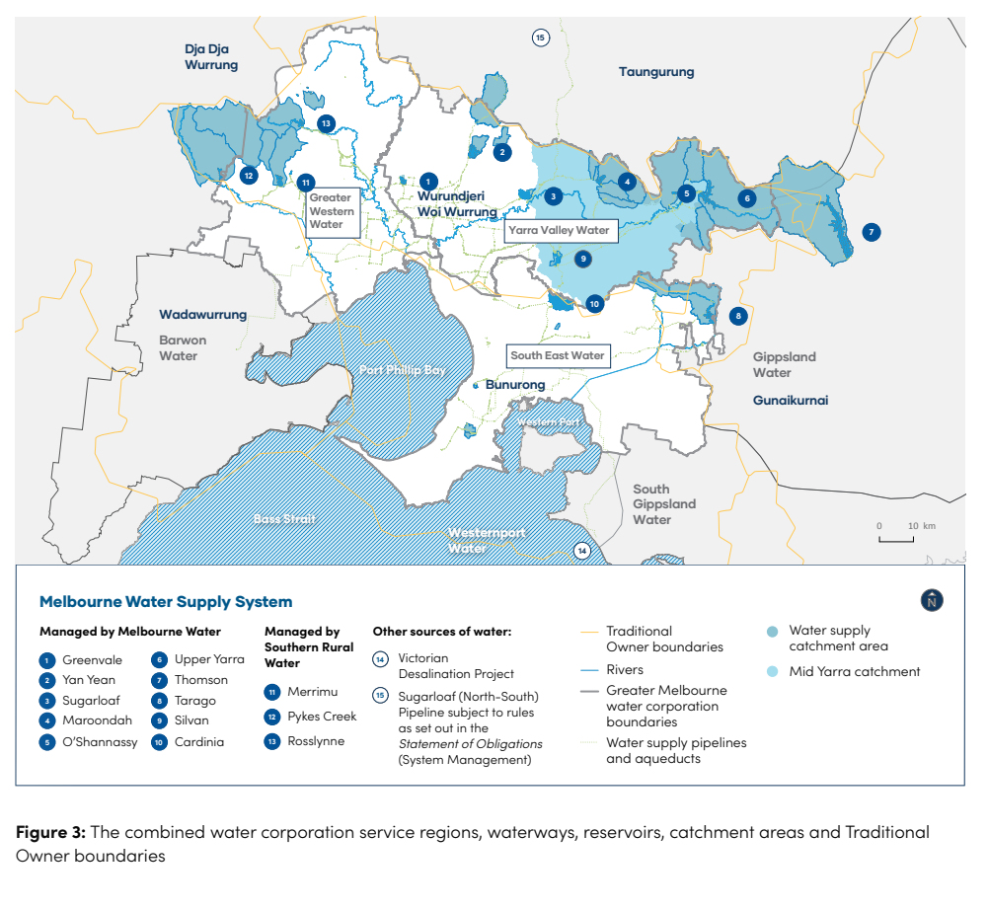
Melbourne’s water wholesaler
Melbourne Water supplies wholesale drinking water, provides sewerage services and recycled water services, integrates drainage systems, builds resilience to flooding, and protects and enhances waterways and land on behalf of the Greater Melbourne community. Melbourne Water also supplies wholesale drinking water to regional water corporations, as well as managing water held by Southern Rural Water for irrigation and the Victorian Environmental Water Holder (VEWH) for environmental releases.
Melbourne’s retail water corporations
The retail water corporations deliver drinking water, sewerage services, recycled water and trade waste services to the community. While more than 90 per cent of our customers are residential, we also deliver water to hospitals, schools, commercial and industrial businesses, as well as water for agricultural use such as on farms.
Greater Western Water
Our newest water service provider, formed in July 2021, bringing together Western Water and City West Water.
1.3 million combined residential and business customers
Service area stretches over 3,700 square kilometres, from Melbourne’s city centre all the way to Lancefield.
Responsible for:
- 7,562 kilometres of water mains
- 6,407 kilometres of sewer mains
- 809 kilometres of recycled water mains
- 57 water pumping stations
- 135 sewage pumping stations
- 7 water treatment plants
- 8 sewage treatment plants
- 13 stormwater harvesting partnership projects funded
- 1 recycled water distribution plant.

South East Water
1.8 million residential customers / 65,000 business customers
Service area stretches over a 3,640 square-kilometre area, from Port Melbourne to Portsea in the south, and from Parkdale to some 30 kilometres east of Pakenham.
Responsible for:
- 14,258 kilometres of water mains
- 11,230 kilometres of sewer mains
- 1,231 kilometres of recycled water mains
- 82 water pumping stations
- 277 sewage pumping stations
- 9 recycled water pumping stations
- 8 water recycling plants
- 1 stormwater treatment plant.

Yarra Valley Water
2 million residential customers / 60,000 business customers.
Service area stretches over 4,000 square kilometres, from Wallan in the north to Warburton in the east.
Responsible for:
- 10,301 kilometres of water mains
- 10,131 kilometres of sewer mains
- 696 kilometres of recycled water mains
- 68 water pumping stations
- 103 sewage pumping stations
- 9 sewage treatment plants
- 3 recycled water plants
- 1 food waste to energy facility.

Our supply system
Rain
Rain is a climate dependent source of water that can be captured to fill our dams, reservoirs and storages. Unfortunately, rainfall cannot meet our growing demand for water and we cannot rely solely on rainfall dependent supply sources to meet all our future water needs.
Balancing all water needs
We use water for a range of residential, commercial, institutional, agricultural and industrial purposes. Restoring Traditional Owner access to water for the purposes of caring for Country and for economic development is critical for the cultural, physical, spiritual and economic health and wellbeing of Aboriginal people. We are committed to ensuring fair and equitable water access for all water users, including to satisfy cultural, liveability and environmental values for all areas across the Greater Melbourne system.
Drainage system
When it rains on urban areas, the drainage system (managed by Melbourne Water and local councils) captures stormwater and channels it into waterways and bays. While this helps to prevent and manage the impacts of urban flooding, it has negative consequences for the environment. Our 50-year Adaptive Plan provides the opportunity to make greater use of stormwater harvesting as a valuable source of supply to contribute to our water needs.
Sewerage system
Most water uses generate sewage that needs to be managed. The sewerage system captures sewage and transfers it to sewage treatment plants, where contaminants are removed so treated sewage can either be used as recycled water, or safely discharged into waterways, the bays or Bass Strait. In 2020/21, Melbourne Water treated 395 GL of sewage, of which approximately 8 per cent (or 32 GL) was supplied to customers as recycled water. With significant quantities of water available close to Melbourne, the sewerage system is an essential part of resolving the growing deficit in our water supply.
Integrated water management
In our current system, rainwater, stormwater and recycled sewage from the sewerage system are harvested for fit-for-purpose uses. The Water for Life strategy considers these critical water resources as part of an IWM approach which recognises stormwater and recycled water can provide more reliable sources of water and build resilience into our future water supply. This reduces the volume of water needed from the water supply system, and reduces the volume of stormwater and treated sewage discharged into waterways and bays. The Adaptive Plan in this strategy identifies IWM solutions that could save up to an additional 70 to 200 GL/year by 2070 across Greater Melbourne.
Water supply system
The water supply system includes protected and open water supply catchments, reservoirs and weirs used to harvest and store water, the Victorian Desalination Project, and the tunnels, pipelines, pump stations and tanks used to transfer water across the region to our customers. The water grid connects Melbourne with neighbouring water supply systems.
Desalination
Desalination is the removal of salt from seawater. The Victorian Desalination Project provides rainfall independent, climate resilient manufactured water for Melbourne’s drinking supply. It can deliver 150 GL per year, which is about one-third of our current demand. We operate the water supply system, including the Victorian Desalination Project, to keep adequate water in storage, subject to cost, for maintaining ongoing supply as well as ensuring we have enough water during future droughts and extreme weather events.
Environmental water
Environmental water is released from our water supply systems into waterways to support environmental values and contribute to maintaining a healthy environment. Although it is primarily planned and delivered to support environmental values, environmental water can also help to support recreational and cultural values, as shared benefits. The Victorian Government has set an ambitious target of almost 100 GL of water to be returned to major rivers in the Central and Gippsland region over the next 10 years to meet environmental outcomes. For the Greater Melbourne and Barwon region this totals approximately 55 GL of environmental water to be returned.
Waterways and bays
The waterways in our region form a complex network of interconnected and interdependent rivers, wetlands and estuaries, which collectively gather rainwater, stormwater and groundwater flows from the landscape (the catchments), ultimately carrying this water to the bays and ocean. Waterways and bays across Port Phillip and Western Port support a range of economic, environmental and social values. The volume and quality of water in our waterways and bays have changed as a consequence of urban development – we need to work to manage the impacts of these changes on the values our waterways and bays support.
Diverse uses of water
Activities like flushing toilets, washing clothes and watering gardens, or irrigating farms, parks and sports fields, do not need water suitable for drinking. For these, we can use treated rainwater, stormwater and recycled water. Using diverse sources of water such as rainwater, stormwater and recycled water for these purposes helps us reduce demand on drinking water and also better care for our open spaces such as parks and sporting grounds. Keeping these areas green, shaded and cool provides more enjoyable places for people to avoid the heat, exercise and spend time outdoors with their community. These spaces can also provide increased food, habitat and other resources for fauna, helping to keep our wildlife healthy. We currently use approximately 45 GL per year of stormwater, rainwater and recycled water for fit-for-purpose uses.

Our challenge
This strategy explores two key challenges impacting Greater Melbourne’s water resources, as identified in Water for Victoria: (1) our growing region and changing needs, and (2) our changing and uncertain climate.
Across Greater Melbourne, our drying climate means less water is flowing in our rivers and captured in our storages. Demand has also increased due to population growth and increased urbanisation.
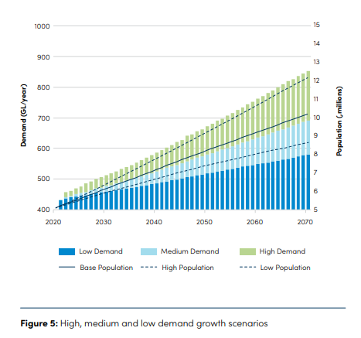
Our growing region and changing needs
Greater Melbourne is a vibrant, growing city with a population of over five million people, expected to double by 2070, which will increase future demand for water (see Figure 5).
Inner suburbs of the city will see strong growth and increased urbanisation – a lot of people in a concentrated area. This will increase the amount of sewage to manage, and more built-up areas will divert more stormwater to our drains. Regional areas are also expected to see continued rapid growth, expanding the footprint of the city and increasing the water needs of our connected regions.
Beyond consumptive water requirements, we also need to provide more water for the environment to protect the health of our already stressed waterways and the ecosystems that depend on them. We are also committed to supporting the Victorian Government in returning water to Traditional Owners to support their cultural needs and values.
Due to wetter-than-average conditions in 2021, annual desalination orders and ongoing water efficiency measures, our water storages are at the strongest position they have been at this time of year since 1997 (as of October 2022). But the overall trend of warmer and drier conditions is expected to continue.

Our changing and uncertain climate
Greater Melbourne’s weather and climate has always been variable. There have been periods of high rainfall causing floods, and periods of low rainfall resulting in droughts. Historically, Melbourne has relied mainly on rainfall dependent water sources from rivers for our water supplies.
However, Victoria’s climate is changing. Since 1910, Victoria has already warmed by 1.2°C and experienced a decrease in average rainfall, an increase in the frequency of extreme heat events and an increase in dangerous bushfire weather.
For Greater Melbourne, we have already seen climate change impacts on our dam inflows from 1997 to the present (see Figure 6). Since 1997, the average inflows into the Melbourne system’s four major harvesting reservoirs has declined by 31 per cent compared to the previous long-term average.
Climate projections suggest future changes could include:
- significant reductions in runoff across Melbourne’s catchments
- droughts becoming more intense and more than twice as likely
- higher average and extreme temperatures more frequently, with the highest temperature increases in our bushfire-prone catchments
- increased severity and frequency of storms, bushfires and heatwaves
- sea level rise of 1 metre by 2100, continuing well into the next century.
Future climate risks and extreme events mean we cannot meet our water needs by using only traditional water supplies. Extreme weather events such as droughts and floods can also damage our infrastructure, waterways and the environment. We will continue to work to understand the risks and to adapt to climate change by developing and implementing climate adaptation plans using the best and most up-to-date science
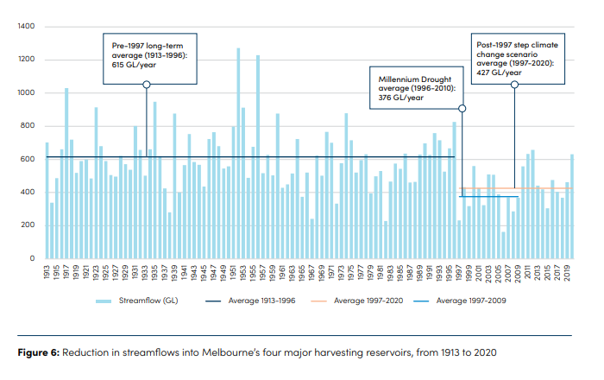
What do these challenges mean for future water supply?
Over the next 50 years, we may need to double our water supply, adding an average of 12 GL of water each year to the Melbourne supply system.
Using climate guidelines published by the Victorian Government in 2020 (DELWP, 2020), combined with the three demand growth projection scenarios, we have assessed how climate change could impact the availability of water from our current supply system over the next 50 years under three projections:
1. High climate change impact and high demand growth
2. Medium climate change impact and medium demand growth
3. Low climate change impact and low demand growth.
Figure 7 shows these projections in our modelling. We have also assessed the impact of climate variability and this has shown a possible range of available supply.
Modelling indicates that by 2030, under high demand and high climate change impact, additional annual water requirements could reach 85 GL. By 2070, this additional requirement could reach 600 GL. While this does not create an immediate risk for Greater Melbourne and connected regional areas, because dams are near-full and we have time to plan and act, we could be exposed to increased risk should we experience another severe drought before our water supplies are augmented. We must be aware that major augmentations can take approximately 8 to 10 years to plan and deliver, and that current modelling indicates that into the future severe droughts could reduce our water storages by 40 per cent over four years.

The current Victorian Desalination Project can provide 150 GL/year, and since 2017 to May 2022 it has contributed almost 450 billion litres of water to our supplies. In our future supply modelling (see Figure 7) we consider it to be used at full capacity.

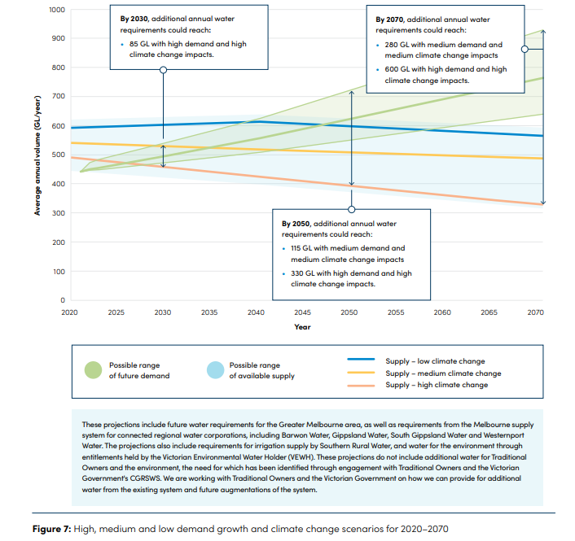
Our system must adapt to these changing conditions. Today, our water storages are high – thanks largely in part to the Victorian Desalination Project which, on average, contributes around one-third of our water supply. However, we know that conditions can change rapidly, and our system is vulnerable to future volatility such as extreme drought depleting our water storages, or extreme rainfall resulting in floods and harm to our waterways.
To address this volatility, and to continue delivering on our customer’s needs, we must start planning now and safeguard our precious supply with a system that is resilient and ready to respond to multiple possible futures.
While our extensive network of dams currently supplies water to Greater Melbourne, under the impacts of climate change their reliance on rainfall cannot meet future demand for water. We also need to consider the broader impacts of dams on communities, waterway health and the environment. We cannot rely solely on dams and the Victorian Desalination Project to meet all our future water needs. This strategy explores these water challenges in detail and outlines an adaptive approach to delivering solutions. A key focus of these solutions is continuing our transition to a future with more climate resilient, manufactured water supplies (desalination, fit-for-purpose recycled water and treated stormwater).

Our approach

There is no single solution to the complex challenges we face. We need to ensure we have secure and sustainable future water supplies, without compromising our surrounding ecosystems.
In developing this strategy we have taken a thorough and robust approach to evaluating all potential water resource management options. We also sought to understand the many ways people use and rely on water today, while achieving balanced access to our precious water supplies.
We have worked together with our customers, community, Traditional Owner groups and the Victorian Government to address the shared challenge of planning for our water future.
Our Water for Life strategy vision: Our Melbourne. Our Water. Our Responsibility.
A future with:
- innovation driving equitable and affordable access to water
- pristine, precious, secure and sustainable water
- meaningful partnerships with Traditional Owners
- meaningful engagement with consumers.
The strategy has been shaped by what Traditional Owners and community members in our service regions told us is important to them. The Greater Melbourne water corporations are committed to achieving this vision through our four key focus areas:
- Ensuring a secure and sustainable water supply.
- Equitably and affordably meeting diverse water needs.
- Ensuring healthy people and a healthy environment.
- Delivering meaningful partnerships, engagement and education

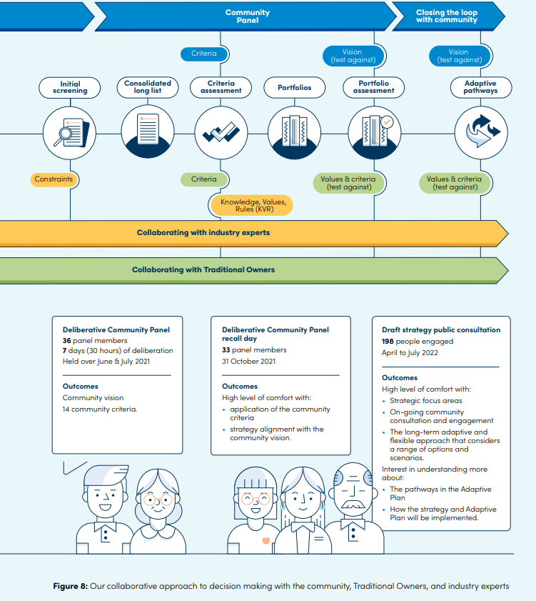
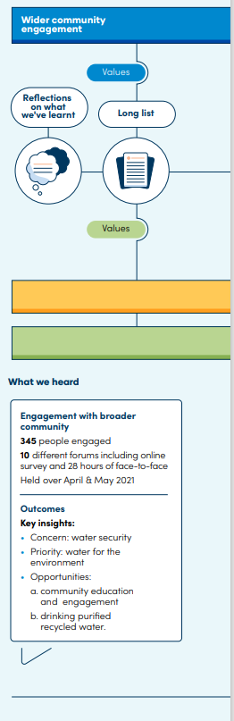

What this strategy will deliver for Greater Melbourne
Water management strategies such as this ensure our systems can respond to growth, while also being resilient to drought conditions that could become more frequent and more severe than those we have experienced in the past.
To maintain and strengthen the resilience of our current system, we have developed a comprehensive set of options for how we respond. These options are grouped into three key themes:
• Supply system augmentations Enhancing and expanding our existing system through climate resilient, manufactured water supplies (desalination, fit-forpurpose recycled water and treated stormwater).
• Water efficiency solutions Reducing demand on the system by continuing our investment in water conservation and efficiency programs. The Adaptive Plan in this strategy identifies water efficiency measures that could save up to an additional 40 to 90 GL per year by 2070 – this will include water efficiency campaigns, regulations and incentives that will help people, businesses and industry all save water. It also includes changing Melbourne’s daily drinking water use target to 150 litres per person per day (down from 155 litres).
• Integrated water management (IWM) solutions Reducing demand on the system by increasing our use of diverse water sources, such as stormwater, rainwater, and fit-for-purpose recycled water. The Adaptive Plan in this strategy identifies IWM solutions that could save up to an additional 70 to 200 GL per year by 2070 across Greater Melbourne.
Under these themes, we have identified pathways that focus on reducing demand on drinking water supply or adding new sources to the supply system. We know that we will need to provide more water for our growing population and rely less on river water as conditions become drier. We know that increased urbanisation will generate more stormwater, which impacts our environment. However, planning for Melbourne’s water needs over the next 50 years must allow for significant uncertainties – including how quickly our population grows, how climate variability will impact water availability and how people will choose to use water.
To manage this uncertainty and future volatility, this strategy is focused on finding more efficient ways to use the water we already have, increasing our use of diverse water sources and transitioning to using more climate resilient, manufactured water supplies (desalination, fit-for-purpose recycled water and treated stormwater). The strategy also considers all water as a potential resource and outlines opportunities to recycle more sewage and harvest more stormwater, which will contribute to and reduce the demand on our drinking supplies.
This strategy takes a best practice adaptive planning approach, which recognises there are multiple ways to respond to uncertainty and aims to keep as many options open as possible. This helps us to make an informed decision at the right time.

This adaptive planning process has confirmed the following:
- We need a lot of water.

To provide the volume of water required, particularly in times of drought, we need to increase our supply of climate resilient, manufactured water. To support population growth and address the impacts of climate change and increasing urbanisation, Greater Melbourne may need 85 GL of additional water by 2030 and 600 GL by 2070. Under a ‘worst case’ future scenario, demand may start exceeding system yield as early as 2023

- There isn’t one single solution

To ensure Greater Melbourne has enough water to meet future demands, we will need a diverse range of water sources. Investment in IWM and water efficiency solutions plays a critical role in making the most and best use of our existing drinking water supplies and deferring progressive large-scale infrastructure investment over the long term.

- We need to start now
Today, while water storages are high, we must take the opportunity to forward plan so that we have a range of fit-for-purpose options ready when needed. Many water supply options take years of planning and investment before they can deliver the water needed. Storage levels can drop quickly and if a severe drought (similar to conditions experienced in 2006/07) were to occur now, modelling indicates that storages could fall by around 40 per cent within four years. Being proactive and prepared allows water corporations to stagger required financial and resource spending over a longer period of time – ultimately lessening immediate cost impacts for our customers.

Delivering resilience and liveability
There is growing global recognition of the need for more flexible, adaptive water systems that are resilient to future uncertainty and the effects of climate change. While we often see the impacts of increasingly dry conditions - such as extreme droughts - climate variability can present in several extremes including floods, bushfires and storms, all of which have a significant impact on our water supplies. Increased urbanisation is also driving demand for open space in urban areas, and water will be essential to enhancing quality of life for communities.
Two key outcomes this strategy will deliver over the next five years are increased system resilience and enhanced community liveability. The Water for Life Adaptive Plan is our roadmap for the future to manage future uncertainty and volatility by continuing to increase our investment in diverse water supplies which provide backup options in distribution and treatment networks, and by installing fire and flood-resistant infrastructure. This will both build buffers in our water networks and provide water for essential cool, green open spaces and healthy urban waterways.

In response, this strategy focuses on the following key deliverables for the next five years:
Ensuring a secure and sustainable water supply
Invest in readiness activities to prepare for the next supply system augmentations.
- We will invest in readiness activities for major augmentations to ensure options are ready to be implemented within four years.
Continue working with Government (via the CGRSWS) to clarify the process for augmentation decisions.
- To enable investment at the right time, our Water Security Framework will identify key decision points through the use of an agreed Augmentation Decision Framework (ADF).
Investigate additional climate independent manufactured water sources
- We will transition to climate independent, manufactured water sources to provide future water security

Equitably and affordably meeting diverse water needs
Invest more in water efficiency initiatives
- We will continue to increase our focus and investment in water conservation and efficiency solutions to reduce demand on the system. This is an immediate and cost-effective response that will help use the water we already have efficiently and maintain affordability for our customers.
Support Government (via the CGRSWS) and deliver on commitments to return water to Traditional Owners and the environment
- In planning for providing water for growing needs into the future, we will support Traditional Owner access to water for protection of waterway health.
Ensuring healthy people, healthy environment
Invest more in IWM solutions
- We will invest in and deliver innovative IWM solutions at the local and regional scale to support community liveability, wellbeing and deliver urban amenity (e.g. urban greening and cooling)
Lead the transition towards greater use of fit-for-purpose recycled water
- We will work together to protect waterway health and the cultural values in our landscapes by making better use of rainwater and stormwater runo , and finding more productive uses for fit-for-purpose recycled water – reducing the demand on our system while providing environmental, economic and liveability benefits.

Meaning partnerships, engagement and education
Empower community to take a more active role in water efficiency
- We will share the true value of water and empower community to take an active role in implementing this strategy through water conservation and behaviour change.
Increase community involvement in future water supply planning
- We will develop a shared plan with our community and Traditional Owner groups. We are committed to empowering and actively involving customers and community in decision making through ongoing meaningful engagement.
Establish partnerships with Traditional Owner groups
- We will establish meaningful partnerships with Traditional Owner groups, working together in water management and planning

Implementation

Throughout the strategy, we have outlined strategic directions and actions we will commit to in order to deliver on each element of our portfolio approach, while remaining prepared to respond to changing conditions.
Victoria’s water resources are managed through various processes and plans and these are regularly reviewed and updated to ensure best practice.
Through ongoing implementation of an adaptive planning approach, we will continue to assess future scenarios and identify options that support delivering multiple benefits for the whole of the Greater Melbourne system. It’s important we continue to work towards greater community water conservation and efficiency as a way of life.
The implementation of this strategy will be subject to ongoing monitoring and evaluation to understand the status of implementation and whether it is achieving the desired outcomes. To support this understanding, implementation of the Adaptive Plan will progressively be refreshed as new information comes to light through:
- periodic system yield assessment
- system optimisation
- research and insights from community and stakeholder engagement and behaviour change programs
- infrastructure studies
- updating risk management plans.
Regular monitoring of the adaptive pathways as information, technology and conditions change will ensure Greater Melbourne remains prepared for an uncertain future. This approach will also allow us to keep multiple pathways, including various water management options and potential solutions, open for as long as possible.
The Adaptive Plan will be implemented consistent with the Water Grid Plan developed as part of the CGRSWS. Together these will provide for carefully planned and sustained increases to available water supply.
Our precious water remains a limited resource – one that we must conserve and protect for future generations.

